Submitted to : Bilal Sir

Submitted by: Mantra Patel

Date: 27 Feb 2025

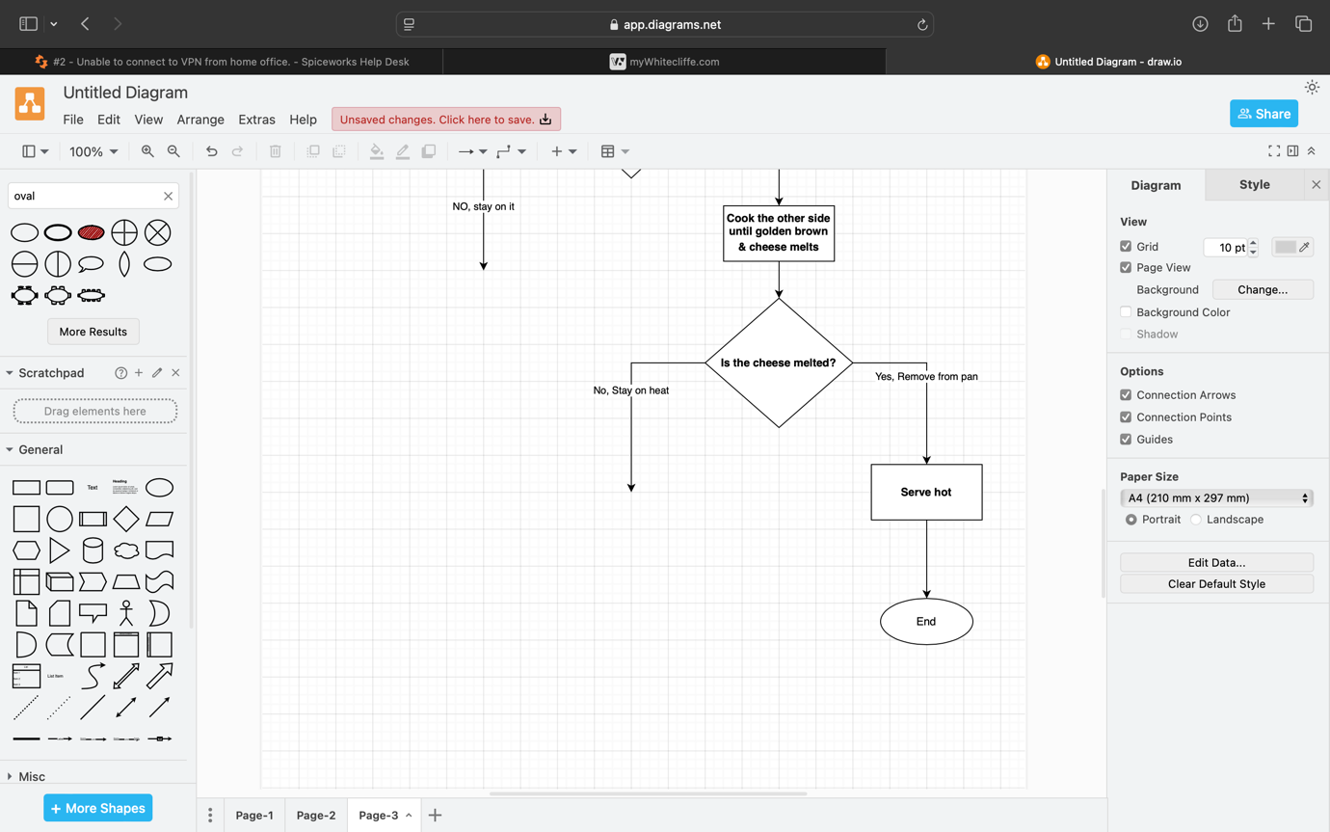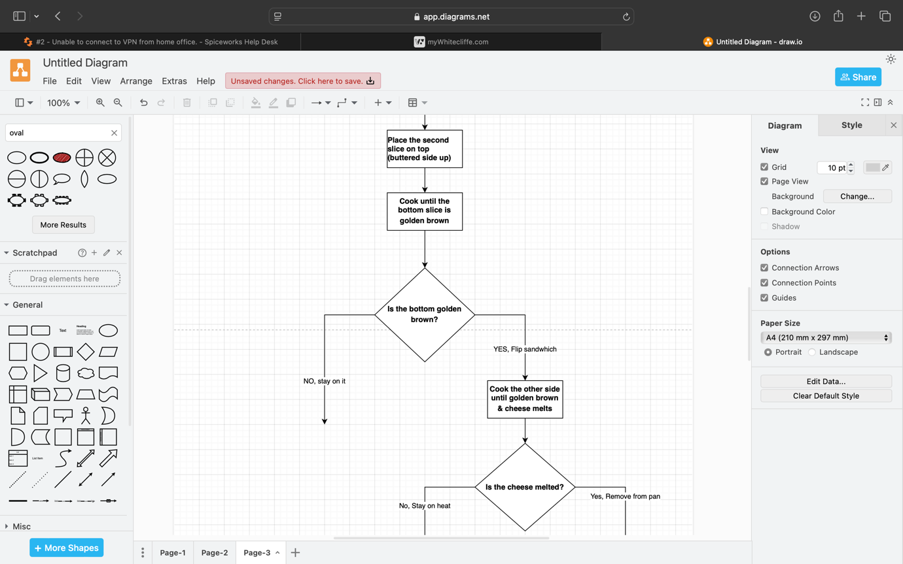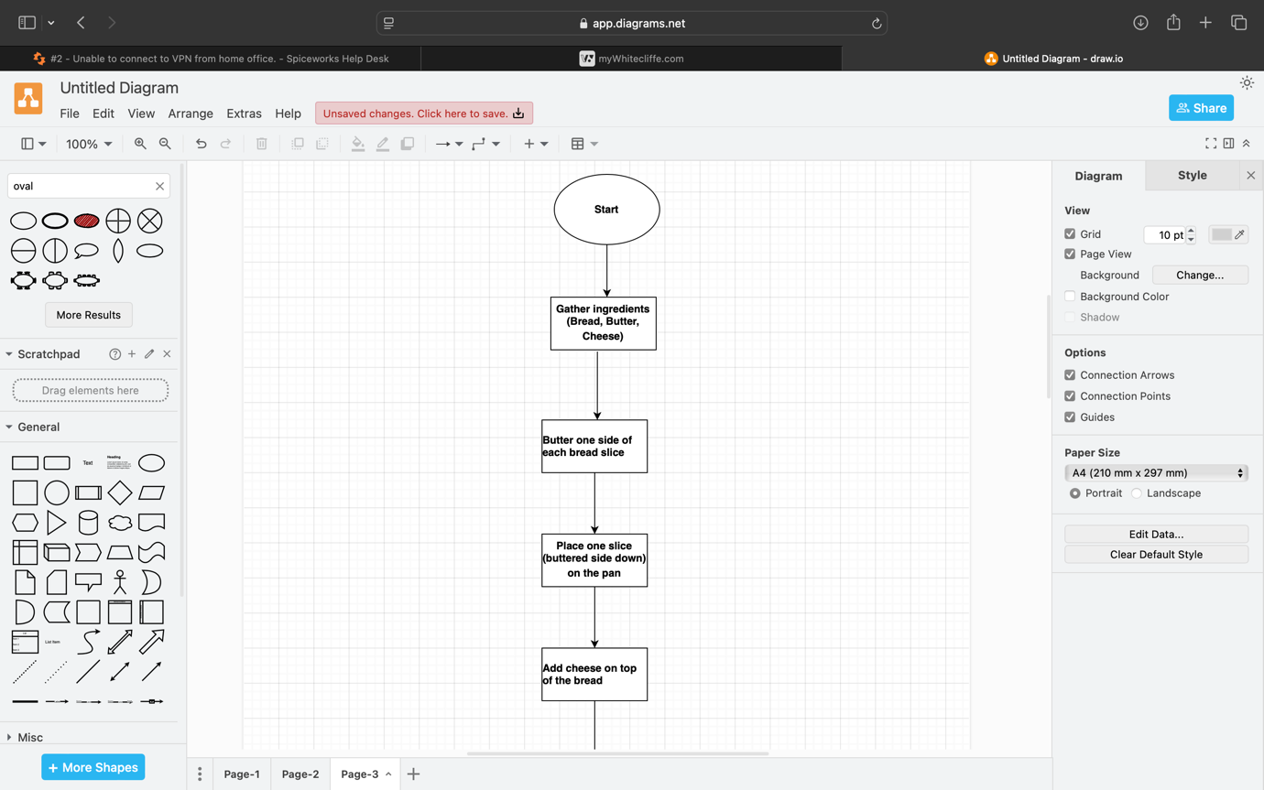

Pseudocode:

BEGIN

// Step 1: Gather ingredients

Place bread butter-side up while getting butter and cheese.

// Step 2: Heat the pan

Set the medium heat level before placing the baking pan.

// Step 3: Prepare bread

Place butter on a single side of every bread slice.

Pearl the first slice of buttered bread into the heated pan.

Set the pan to medium heat then place a buttered bread slice butter-side down into the pan.

// Step 5: Add cheese

Place cheese on top of the bread surface before proceeding.

Step 6 involves placing the second bread slice with buttered surface facing upward.

Put the second bread slice butter-side facing up on the surface.

// Step 7: Cook the sandwich

Put the sandwich in the pan until the very first piece of bread turns uniformly brown

WHILE bottom_not_golden_brown DO

WAIT

END WHILE

// Step 8: Flip the sandwich

DISPLAY "Flip the sandwich"

// Step 9: Cook the other side

Regulate the pan to cook both surfaces of the sandwich until the bread becomes golden brown with melted cheese.

WHILE cheese_not_melted DO

WAIT

END WHILE

// Step 10: Finish

The sandwich needs removal from pan before serving hot.

END